# 7.4 Custom Program Design

## What I Have Created

The custom program I have created is a game where tanks battle each other on a destructible terrain. It is a naïve recreation of the core functionality in the classic game Scorched Earth: <http://www.abandonia.com/files/games/70/Scorched%20Earth_5.png>

I aimed to create a relatively complete application, with the standard game states expected by users, full gameplay including menu controls, game physics, sounds, computer opponents and randomized elements to improve gameplay.

A demonstration video can be found here: <https://youtu.be/09NeqEEkkf0>

## Solution Architecture

Below is a diagram of the models (also “main” and “shared” utilities) comprising the application architecture.

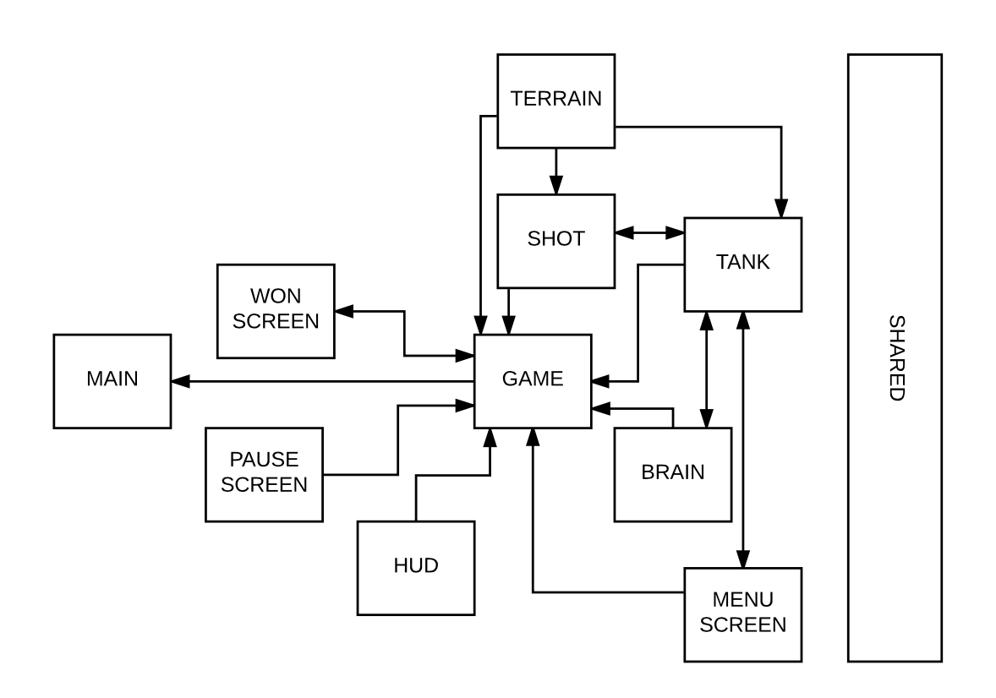

These models each have a .cpp file and a header file.

The following custom types are used in the program:

|  |  |  |
| --- | --- | --- |
| Aggregate Type | Type | Purpose |
| enum | game_state | States the game can be in |
| enum | brain_state | States the computer brain can be in |
| struct | terrain | Attributes of the current game terrain |
| struct | shot | Attributes of a shot that has been fired |
| struct | brain | Attributes for a computer player’s planning |
| struct | tank | Represents a player (human or computer) |
| struct | ui_element | An individual interactible element of ui |
| struct | player_toggle | The toggle between human and computer |
| struct | menu_screen | All the ui elements in the menu screen |
| struct | won_screen | All the ui elements in the won screen |
| struct | game | The whole game |

## Flow Through Key/Golden Path

There are many branches and possibilities; a simplified path through the application showing some of the key functions/procedures is shown on the next page.

Each box and textbox with an arrow in the diagram is a function or procedure (it is conceptually similar to a sequence diagram).

Note that many of the arrows point to functions and procedures that actually call more functions and procedures. The subsequent calls have been omitted to present an accessible representation of the program. The application is relatively large, at 2678 lines including both header and C++ files.

